

Pizza Delivery Activity

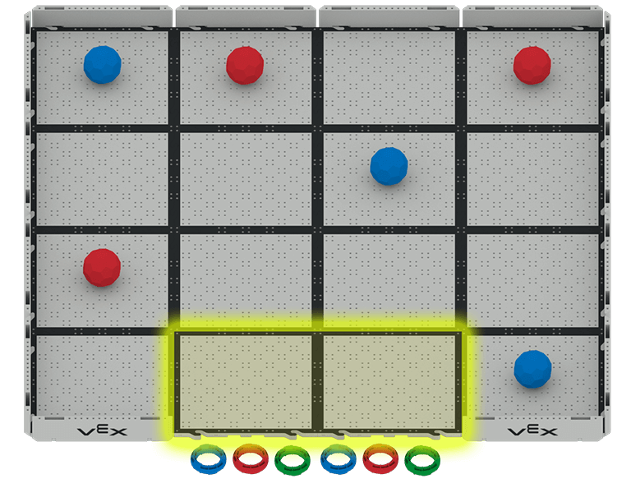 | Drive the Speed Build to successfully deliver pizzas to houses in this tasty challenge!

Challenge: Deliver A Pizza to Each House on the Field
To deliver a pizza (Ring) to a house , the robot will carry a pizza from the Pizza Shop to the house (Buckyball), pause to drop off the pizza, and then return to the Pizza Shop (shown in yellow above).

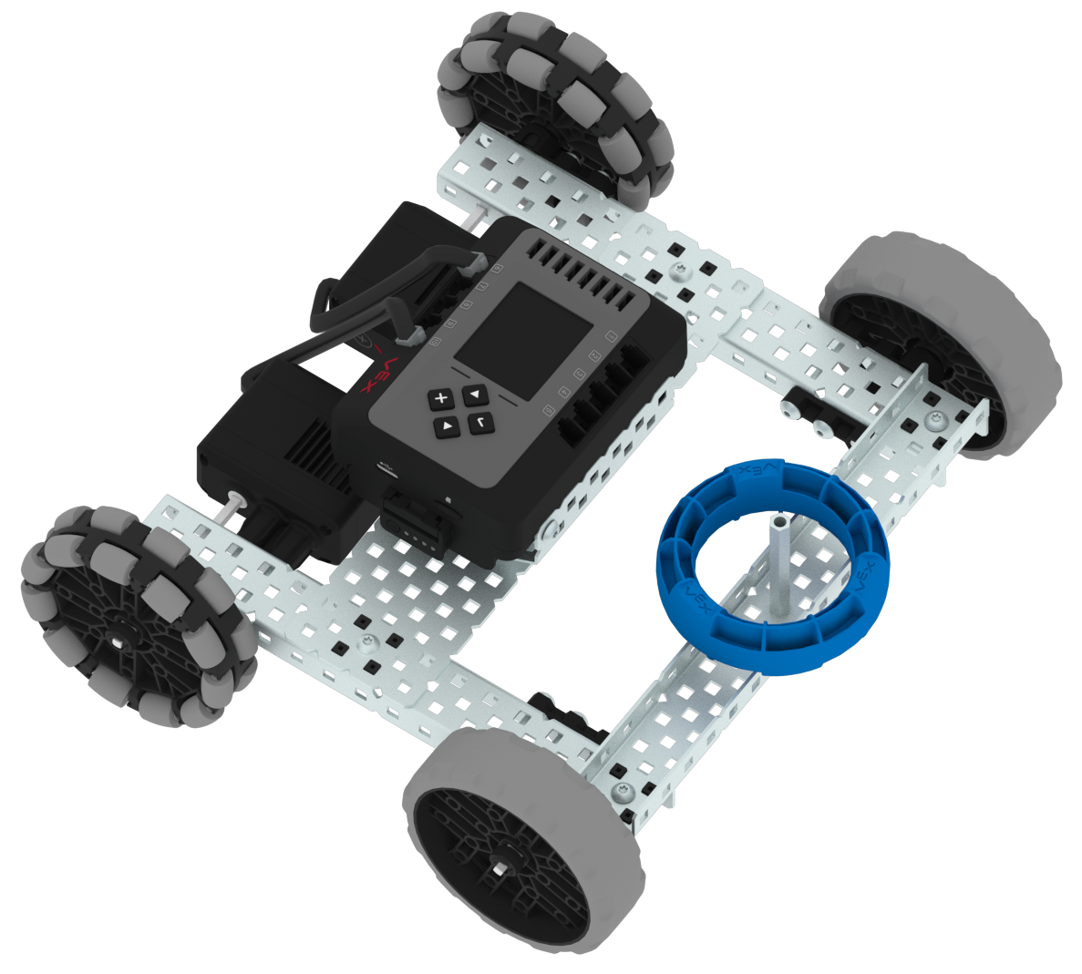
Set Up and Rules:
- Complete the challenge using your VEX EXP Speed Build with the added standoff, and the built-in Drive Program.
- Pizzas can only be delivered one at a time.
- The robot can start anywhere in the Pizza Shop.
- If the robot touches a house, or if a pizza falls off the robot during delivery, stop driving and try again.
- Reset the Field before each run.

Drive Mode Reminders
 | Left Arcade  Drive forward, reverse, left, and right using only the left joystick.
 | Right Arcade  Drive forward, reverse, left, and right using only the right joystick.
 | Split Arcade  Drive the robot left and right using the left joystick, and forward and reverse using the right joystick.
 | Tank Drive  Drive the robot's left motor using the left joystick, and the right motor using the right joystick.

Pizza Delivery
Activity Notes

Hands-on time for this activity is approximately one hour.

Preparing for the Activity

Additional materials needed for each group: (recommended group size is two-three students):
- Pre-built VEX EXP Speed Build
- 4 x 4 Field (with walls), or a taped-off 4-foot square space
- 6 Buckyballs (any color) to mark houses
- 6 Rings (any color) to act as pizzas

Set Up the Field As Shown:
- Remove the two walls near the Pizza Shop (marked as the two yellow highlighted Field tiles in the image to the right).
- Place 6 Buckyballs to represent houses in the Field orientation shown.
- Place 6 Rings that represent the pizzas for each house in front of the Pizza Shop.

Facilitating Castle Crasher

- Introduce the activity. Share the context here to help students connect what they will do with the robot to real-world applications.
 | Robotics challenges can look simple at first: drive forward, turn, hit the target. But once the timer starts, engineers quickly discover that small decisions can make a big difference. In Pizza Delivery, your team will take on a robotics challenge with clear constraints: a field to navigate, pizzas to deliver, and a limited amount of time to deliver pizzas to the right locations. To succeed, you will need more than driving skill. You will need a plan, communication, and a willingness to adjust your strategy based on what you learn.  As you work, focus not only on what your robot does, but on how your team solves problems together. Share ideas, test strategies, learn from each run, and look for ways every team member can contribute.

- Introduce how to drive the robot using the Driver Control Program. Walk students through the steps to begin driving the robot. Use this article for reference.
  - Have students explore the different ways the robot can move using the joysticks.
  - Show them how to change the Drive Mode on the EXP Brain. Give them time to practice driving in a square to try out each of the different Drive Modes. They do not need to drive on the fields - driving on the floor is fine for this part of the activity.
  - Bring students together to check for understanding using the following prompt:
    - Which Drive Mode was most comfortable for you? Why?
- Direct students to add a standoff to the front center of the robot to hold the Ring during pizza delivery. This is also shown in the image to the right. They will need:
  - 1 – Standoff 2.00”
  - 1 – Star Drive Screw 8-32 x 0.375"
  - 1– Star Drive Screwdriver or T15 Star Drive Key

- Direct students to start the Pizza Delivery activity:
  - Move around the room and talk with students, asking questions like:
    - What house did you choose to deliver your first pizza to and why?
    - Did it work the first time? If not, what did you do differently the second time?
    - What Drive Mode did you use to deliver the pizza?
  - The robot can start anywhere inside the Pizza Shop with one pizza loaded onto the standoff. The goal is to deliver a pizza to a house, then return to the Pizza Shop to pick up another.
    - When delivering a pizza, the Ring can be placed on top of the Buckyball, or anywhere within that house’s Field tile.
    - Only one pizza should be delivered to each house.
  - When delivering a pizza, pause the robot for delivery. It should pause again when it returns to the Pizza Shop, giving time for the next Ring to be loaded onto the standoff.
  - The color of the pizzas and the order of the houses they are delivered to do not matter. There are many valid approaches and combinations as long as all 6 pizzas are delivered.

Extending the Activity

- Have students build the robot as part of the workshop. Allow approximately 45 minutes for groups to build the Speed Build.
- Create a workshop challenge! Have a friendly competition to see which group can deliver pizzas the fastest! You can use the EXP Leaderboard to keep track of students’ progress in a central location.

